## Lab 2

Your name and student number must be at the top of every file.

You cannot use <string>or anything else except char ,ints and an array of chars.

Apart from cout, you **can only use functions that you have written**.

You may ask for some help but the code must be substantially yours.

All code must be consistently indented and variables given appropriate names.

// dont use cout in any of the functions apart from PrintArray();

//Find the largest value in the entire array and replace all occurrences with - 1. Return the largest value found.

int ReplaceLargestValue(int array[4][6])

{

return 0;

}

//Count all zero values and replace them with - 1. Return the count of zeros.

int CountAndReplaceZeros(int array[4][6])

{

return 0;

}

//Find any horizontal sequence of 3 consecutive cells matching the given pattern.Replace with - 1 and return matches found.

int ReplaceRowPattern(int array[4][6], int pattern[3])

{

return 0;

}

//Swap two specified rows in the array.

void SwapRows(int array[4][6], int row1, int row2)

{

}

//Calculate and return the sum of all values in specified column(ignore - 1 values).

int FindColumnSum(int array[4][6], int col)

{

return 0;

}

//Replace all border elements(first / last row, first / last column) with - 1. Return count replaced.

int ReplaceBorder(int array[4][6])

{

return 0;

}

//Count how many different unique values exist in the array(ignore 0 and -1).

int CountUniqueValues(int array[4][6])

{

return 0;

}

//Reverse each row of the array(first element becomes last, etc.).

void ReverseArrayRows(int array[4][6])

{

}

//Find and return the value that appears most frequently(ignore 0 and -1).

int FindMostFrequent(int array[4][6])

{

return 0;

}

//Shift all elements one position to the right.Last column moves to first column.

void ShiftArrayRight(int array[4][6])

{

}

int ReplaceWithMinusOne(int array[4][6]) **30 Marks**

The level is stored as an array of integers starting off with values 1 to 4 for. 0’s are not included.

Starting from 0,0 in the array test each column in the first row, then the second row , going from left to right until the end of the array is reached

Find **One** cluster of 3 or more identical items connected horizontally or vertically. Check for a horizontal line first and then a vertical line for each array position in turn.

Score the cluster by adding up the values (1 to 4) in the cluster.

Replace that cluster with ‘-1’s and returns a score

Example

Before

{ {0,0,3,1,3,4},

{0,0,2,3,4,3},

{0,0,1,3,3,2},

{0,0,2,2,2,2} };

After:

{ {0,0,3,1,3,4},

{0,0,2,3,4,3},

{0,0,1,3,3,2},

{0,0,-1,-1,-1,-1} };

Score would be 8

Return 8.

void PrintArray(int array[4][6]) **10 Marks**

Print the array in rows and columns. Only function you use cout.

FallDownAndReplace(int array[4][6]) **30 Marks**

‘Remove’ the -1’s in the array and the items above fall into their position. All items above fall into the ‘empty’ position below them.

New items are added to the top of the array with values of -2 and will not be part of the next cluster.

Example

Before :

{ {0,0,3,3,4,3},

{0,0,-1,3,4,3},

{0,0,-1,3,3,2},

{0,0,-1,2,3,3} };

After:

{{0,0,-2,3,4,3},

{0,0,-2,3,4,3},

{0,0,-2,3,3,2},

{0,0, 3,2,3,3} };

**Testing**

Create tests that you did to show that the code is tested well. It is up to you to demonstrate that it works correctly.

A.

void FindAllVariables(char variables[], char code[]) **15 Marks**

Write a function that takes 2 array of chars as parameters. The function fills the variable array to contain a comma separated list of the variable names that are declared in the code in the string. Only variables of type “int” and “char” need be included. Only one variable is declared per line.

Both variables array and code array have a max on 1000 chars.

Note strings are terminated by a 0.

For example

char code[1000] = “int main() \n{ \n int var1=10;\n int var2 =10;\n if(var1<10) \n {\n int var3=20;\n} \n}\ n”;

char newline = ‘\n’;

char variables[1000] ;”

FindAllVariables(variables ,code);

//variables now contains “var1,var2,var3”

B.

void FindVariablesInScope(char variables[], char code[], int lineNumber) **15 Marks**

Find variables in scope after a particular line number. The code won’t contain “for” loops. Only variables of type “int” and “char” need be included. Only one variable is declared per line. The only function declaration in the code is “int main()”.

Example:

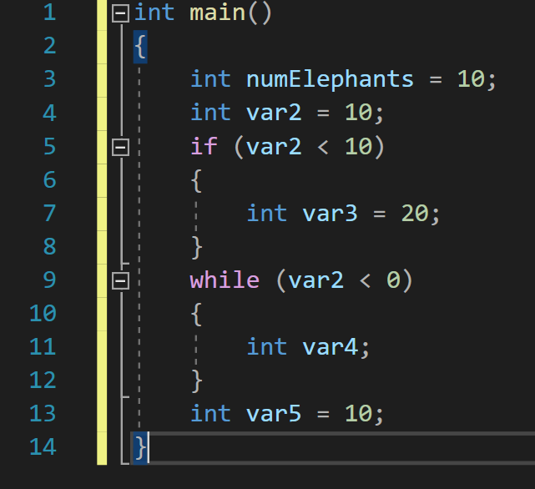

char code[1000] = “int main()\n{ \n int numElephants = 10;\n int var2 = 10; \n if (var2 < 10)\n{\nint var3 = 20;\n}\n while(var2 < 0)\n { \n if (var2 == 10) \n { \n int var4; \n } \n int num = 10; \n } \n int var5 = 10; \n }”;

char variables[1000] ;

FindVariablesInScope(variables,code,17); // the line with “int var5 = 10;”

//variables now contains “numElephants,var2,var5”

FindVariablesInScope(variables,code,13);

//variables now contains “numElephants,var2,var4”

**Testing**

Create tests that you did to show that the code is tested well. It is up to you to demonstrate that it works correctly.